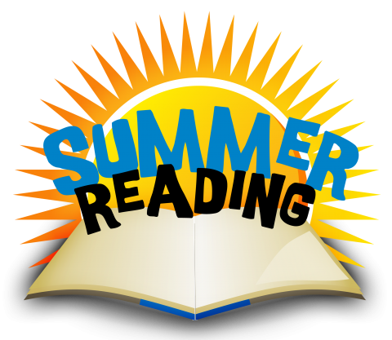
June 1, 2021

Dear Parents,

The end of the school year is almost here and we are gearing up for summer reading! Students will be able to check out five library books to keep at home over the summer break. Students will get bags and go book shopping during their library time on Thursday 6/3, but the book bags will not go home until Friday 6/11. Also on that Friday, we will be kicking off our summer reading challenge by having the whole school read together outside for 20 minutes. The goal is for every student to read for 24 hours this summer, and record every 20 minutes read by filling in a circle on their log. (If your child reads for just 20 minutes every day this summer, they will have read for over 24 hours!)

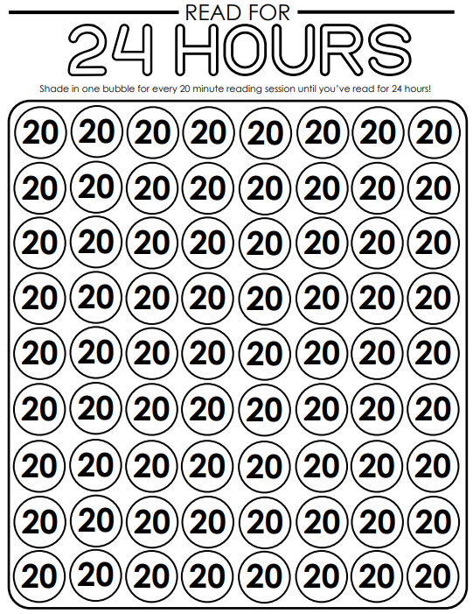

The log will go home in students’ book bags on 6/11, along with suggestions for fun activities, bookmarks, and information about the Governor’s Reading Challenge at the Norfolk Public Library. We encourage you to visit the Norfolk library this summer to check out books and experience their fun activities! The Botelle School library will also be open on the following days for book exchanges:
- Thursday July 15, 9:00-12:00
- Thursday August 12, 3:00-6:00

Thanks for your support in making reading a priority for your child this summer. There are worlds to explore inside those pages!

Sincerely,

Mrs. Valentino, Mrs. Dubecky and Mrs. Incillo

